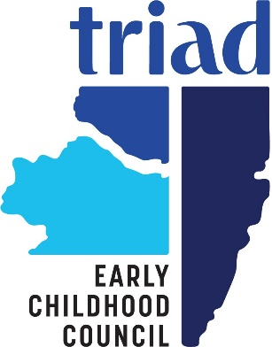

TRIAD EARLY CHILDHOOD COUNCIL
CHILDREN’S CHAMPION AWARDS

The Children’s Champion award is designed to recognize those individuals and organizations that are going above and beyond the requirements of their job to ensure that services for children birth – 8 in Clear Creek, Gilpin, and Jefferson counties are comprehensive, equitable and accessible. The award was first presented in 2008 and has been given to a variety of individuals and organizations. This year we are seeking nominations of “unsung heroes”, individual child care providers or centers. Nominees may be a licensed Family Child Care Home, Center/Preschool, or staff member of such with the following characteristics:

- They collaborate within the community, working across the domains of early learning, health, and family support. That means that they are actively partnering with many different organizations (Triad, health department, DDRC, DHS, JCMH, Jeffco ARC, business community, faith community, political system, etc.).
- Invest significant amounts of time and or resources. We are looking for those who go over and above in terms of making sure that things get done or who find ways to leverage more resources for activities that enhance services for young children and their families.
- Improve the quality, access, and equity of services for young children and their families in Clear Creek, Gilpin and/or Jefferson Counties. This could be things like hosting informational sessions or providing information about community resources, ways to improve quality for child care or who finds ways to increase the availability of services (either in number or variety) in the Triad communities. It could also be someone who finds ways to increase the access that families with low income or families who have children with disabilities can access services that are in the community. These are just a few examples.
- Nominations will only be accepted from consumers of child care services, about their specific provider.
- We urge those submitting nominations to think consider work that has directly impacted a specific child or family

All nominees will be recognized, and award winners will be announced at the Children’s Champion Awards Dinner on June 2, 2026.

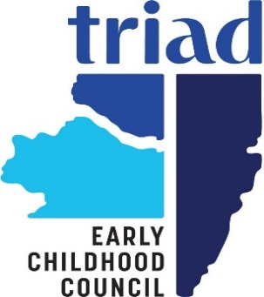

Nomination Form

Your Name:
Age(s) of Child(ren) Enrolled:
Phone Number:
Email:

Name of Nominee:

License Number of the Nominee:

Phone Number:

Email:

Please give a brief description of why you feel this provider should receive the Triad Children’s Champion Award.

Describe how this candidate has worked to:
- assist your family/child by making connections to needed resources
- invest significant amounts of time and/or resources
- improve the quality, access, and availability of services

Give specific examples of how your family or child has been impacted. Use an additional sheet of paper if necessary.

Submit by 3:00 pm April 30, 2026 to: tamla.woldemariam@childcareinnovations.org

